##### TERRE D'HERMES

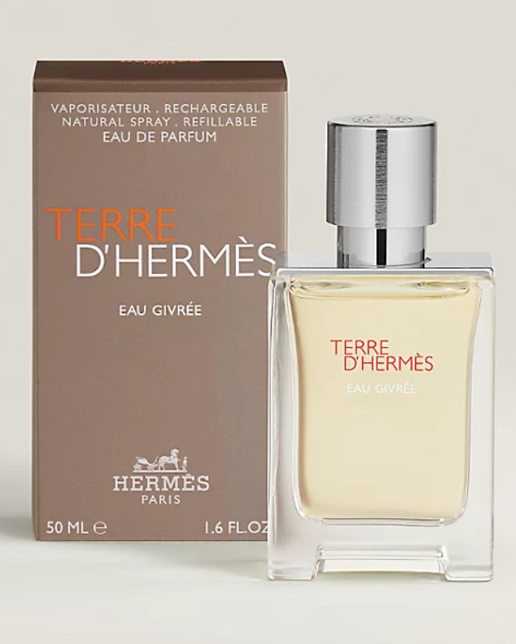**Terre d'Hermès** by **Hermès** is a Woody Spicy fragrance for men. **Terre d'Hermès** was launched in 2006. The nose behind this fragrance is Jean-Claude Ellena. Top notes are Orange and Grapefruit; middle notes are Pepper, Pelargonium and Flint; base notes are Vetiver, Cedar, Patchouli and Benzoin. This perfume is the winner of award **FiFi Award Fragrance Of The Year Men`s Luxe 2007**.

Terre d’Hermès: conceived in 2006 by Jean-Claude Ellena, Terre d’Hermès is a metaphor for materials, a matrix that speaks of territory as well as matter, earth, and roots.This vertically structured scent is based on an alchemy of wood, the scent first introduces the gaity of orange, the bitterness of grapefruit and the vivacity of pepper and of fresh spices. This “vegetality” flirts with the mineral effect of flint and the coarseness of vetiver. Dominated by cedar, the fragrance goes deeper with the sweetness of resins and the impalpable voluptuousness of benzoin.